Task 1:

#include <iostream>

using namespace std;

class class1 {

private:

static int count;

public:

class1()

{

cout << "This is class 1" << endl;

count++;

}

static int objectCount()

{

return count;

}

~class1()

{

}

};

int class1::count;

int main()

{

class1 obj1, obj2, obj3;

cout << "Number of objects:" << class1::objectCount()<<endl;

}

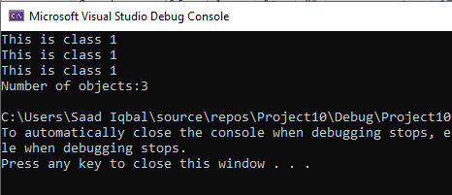

Task 2:

#include <iostream>

using namespace std;

class abc {

private:

static int a;

static int b;

public:

abc()

{

cout << "This is class 1" << endl;

}

static void call()

{

static int a=12;

static int b = 34;

cout <<"a=" <<a<<endl;

cout << "b="<<b << endl;

}

~abc()

{

}

};

int main()

{

abc::call();

system("pause");

}

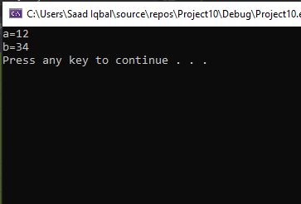

TASK 3:

#include <iostream>

using namespace std;

class abc

{

public:

static int Fact(int x);

};

int abc::Fact(int x)

{

if (x <= 1.0)

return 1.0;

else

return x * Fact(floor(x - 1));

}

int main()

{

int num;

cout << "Enter a Number : ";

cin >> num;

cout << endl<<"Factorial iS " << abc::Fact(num) << endl;

system("pause");

}

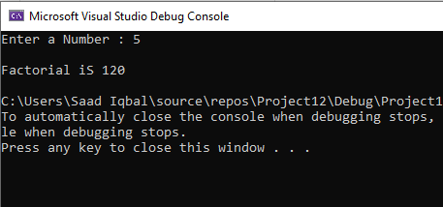

TASK 5;

#include<iostream>

using namespace std;

class date

{

const int day;

const int month;

const int year;

public:

date():day(0), month(0),year(0)

{

}

date(int d, int m, int y) : day(d), month(m), year(y)

{

}

void display() const

{

cout << "Date is : " << day << "/" << month << "/" << year << endl;

}

};

int main()

{

const date obj(12, 3, 2020);

obj.display();

system("pause");

}

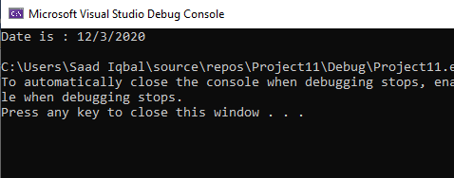

Task 6:

#include<iostream>

#include<string>

using namespace std;

class person

{

public:

char COOK;

int n;

string input;

int store, store1;

char var;

string NAME;

void setname(string);

string getname(string);

void setage(int);

int getage(int);

int setgen(char);

int setgetcook(char);

string getoccu(string);

private:

string name;

bool cook = false;

bool gender = false;

char gend;

char ck;

int age;

string Occu;

~ person

{

cout<<”This is destructor”<<endl;

}

};

person p1, p2;

void person::setname(string NAME)

{

name = NAME;

}

string person::getname(string NAME)

{

return name;

}

void person::setage(int n)

{

age = n;

}

int person::getage(int n)

{

return n;

}

int person::setgen(char var)

{

if (var == 'M' || var == 'm')

{

gender = true;

return gender;

}

if (var == 'f' || var == 'F')

{

gender = false;

return gender;

}

}

int person::setgetcook(char cook)

{

if (cook == 'y' || cook == 'Y')

{

cook = true;

return cook;

}

else

{

cook = false;

return cook;

}

}

string person::getoccu(string occ)

{

Occu = occ;

return occ;

}

int main()

{

cout << "Enter Your Name: ";

getline(cin, p1.NAME);

cout << "Enter Your Age: ";

cin >> p1.n;

cout << "Enter Choice (F||M): ";

cin >> p1.var;

cout << "Enter Your Choice{Y||N): ";

cin >> p1.COOK;

cin.ignore();

cout << "Enter Your Occupation: ";

getline(cin, p1.input);

p1.store = p1.setgen(p1.var);

p1.store1 = p1.setgetcook(p1.COOK);

p1.setname(p1.NAME);

p1.setage(p1.n);

if (p1.store == true)

{

cout << "your Name Is " << p1.getname(p1.NAME) << endl;

cout << "Your Age Is: " << p1.getage(p1.n) << endl;

cout << "You Are Male!" << endl;

}

else

{

cout << "your Name Is " << p1.getname(p1.NAME) << endl;

cout << "Your Age Is: " << p1.getage(p1.n) << endl;

cout << "You Are Female!" << endl;

}

if (p1.store1 == true)

{

cout << "Your Are Cook!" << endl;

}

else

{

cout << "Your Are Not Cook!" << endl;

}

cout << "Your Occupation Is " << p1.getoccu(p1.input) << endl;

cout << "Enter Your Name: ";

getline(cin, p2.NAME);

cout << "Enter Your Age: ";

cin >> p2.n;

cout << "Enter Choice (F||M): ";

cin >> p2.var;

cout << "Enter Your Choice{Y||N): ";

cin >> p2.COOK;

cin.ignore();

cout << "Enter Your Occupation: ";

getline(cin, p2.input);

p2.store = p2.setgen(p2.var);

p2.store1 = p2.setgetcook(p2.COOK);

p2.setname(p2.NAME);

p2.setage(p2.n);

if (p2.store == true)

{

cout << "your Name Is " << p2.getname(p2.NAME) << endl;

cout << "Your Age Is: " << p2.getage(p2.n) << endl;

cout << "You Are Male!" << endl;

}

else

{

cout << "your Name Is " << p2.getname(p2.NAME) << endl;

cout << "Your Age Is: " << p2.getage(p2.n) << endl;

cout << "You Are Female!" << endl;

}

if (p2.store == true)

{

cout << "Your Are Cook!" << endl;

cout << "Your Occupation Is " << p2.getoccu(p2.input) << endl;

}

else

{

cout << "Your Are Not Cook!" << endl;

cout << "Your Occupation Is " << p2.getoccu(p2.input) << endl;

}

}

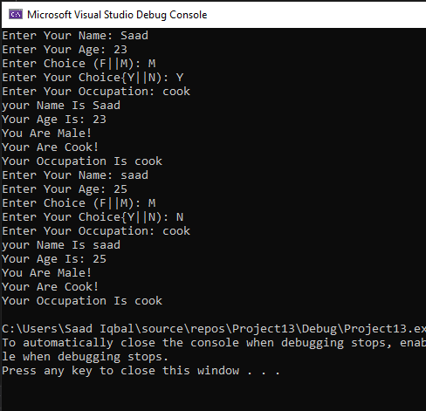

TASK 7:

#include<iostream>

#include<string>

using namespace std;

class Employee

{

string id;

string name;

string department;

string bankaccountnumber;

string Grade;

public:

Employee()

{

id = ' ';

name = ' ';

department = ' ';

bankaccountnumber = ' ';

Grade = ' ';

}

Employee(string id,string name,string department,string bankaccountnumber,string Grade)

{

id = 1234;

name = "Saad";

department = "CS";

bankaccountnumber = 1234567;

Grade = 1;

}

void inputdata()

{

cout << "Enter id of the employee" << endl;

cin >> id;

cout << "Enter name of the employee" << endl;

cin >> name;

cout << "Enter department of the employee" << endl;

cin >> department;

cout << "Enter bankaccountnumber of the employee" << endl;

cin >> bankaccountnumber;

cout << "Enter Grade of the employee" << endl;

cin >> Grade;

}

void display() const

{

cout << "The id of the employee" << id << endl;

cout << "The name of the employee" << name << endl;

cout << "The department of the employee" << department << endl;

cout << "The bankaccountnumber of the employee" << bankaccountnumber << endl;

cout << "Enter Grade of the employee" << Grade << endl;

}

};

int main()

{

Employee *obj = new Employee[3];

for (int i = 0; i < 3; i++)

{

cout << "Enter the data of employee " << i + 1 << ":"<<endl;

obj[i].inputdata();

cout << endl;

}

for (int i = 0; i < 3; i++)

{

cout << "The data of employee " << i + 1 << ":";

obj[i].display();

cout << endl;

}

}

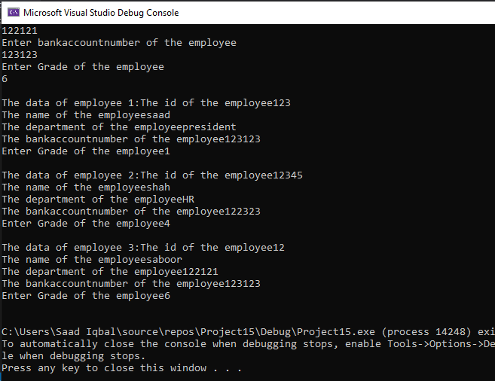

TASK 8:

TASK 8:

#include<iostream>

#include<string>

using namespace std;

class person

{

private:

string name="Saad";

const string dob="1/jan/2000";

static int count;

const int CNIC=12132323;

public:

person() :dob(0),CNIC(0)

{

name = " ";

count = 0;

}

void dob()const

{

cout << "The date of birth is :" << dob;

}

void CNIC()const

{

cout << "The CNIC is :" << CNIC;

}

static int objectCount()

{

return count;

}

void display()const

{

cout << "Mr. " << name << " "<<"dob "<< dob<<"CNIC= "<<CNIC<<endl;

}

};

int count = 0;

int main()

{

const person obj;

obj.display();

obj.objectCount();

}

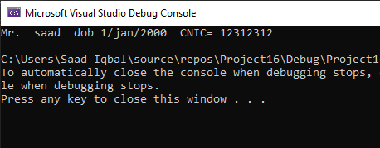

Task 9:

#include<iostream>

#include<string>

#include<iomanip>

using namespace std;

class Employee {

private:

string name;

string Dept;

string position;

int idNumber;

public:

string Name, Department, Position;

int id_Input;

Employee()

{

name = "";

Dept = "";

position = "";

idNumber = 0;

}

void setName(string);

string getName();

void setDepart(string);

string getDepart();

void setPosition(string);

string getPosition();

void setID(int);

int getID();

void Print();

void Simple();

~ Employee

{

cout<<”This is destructor”<<endl;

}

};

Employee emp, emp1, emp2, emp3;

void Employee::setName(string Name)

{

name = Name;

}

string Employee::getName()

{

return name;

}

void Employee::setDepart(string Depart)

{

Dept = Depart;

}

string Employee::getDepart()

{

return Dept;

}

void Employee::setPosition(string Posit)

{

position = Posit;

}

string Employee::getPosition()

{

return position;

}

void Employee::setID(int identity)

{

id_Input = identity;

}

int Employee::getID()

{

return id_Input;

}

void Employee::Simple()

{

cout << "Name" << setw(30) << "Id Number" << setw(30) << "Department" << setw(30) << "Position" << endl << endl;

}

void Employee::Print()

{

cout << getName() << setw(30) << getID() << setw(30) << getDepart() << setw(30) << getPosition() << endl;

}

int main()

{

cout << "Enter Name of Employee: ";

getline(cin, emp1.Name);

cout << "Enter Id of Employee: ";

cin >> emp1.id_Input;

cin.ignore();

cout << "Enter Department of Employee: ";

getline(cin, emp1.Department);

cout << "Enter Position of Employee: ";

getline(cin, emp1.Position);

emp1.setName(emp1.Name);

emp1.setDepart(emp1.Department);

emp1.setPosition(emp1.Position);

emp1.setID(emp1.id_Input);

cout << "Enter Name of Employee: ";

getline(cin, emp2.Name);

cout << "Enter Id of Employee: ";

cin >> emp2.id_Input;

cin.ignore();

cout << "Enter Department of Employee: ";

getline(cin, emp2.Department);

cout << "Enter Position of Employee: ";

getline(cin, emp2.Position);

emp2.setName(emp2.Name);

emp2.setDepart(emp2.Department);

emp2.setPosition(emp2.Position);

emp2.setID(emp2.id_Input);

cout << "Enter Name of Employee: ";

getline(cin, emp3.Name);

cout << "Enter Id of Employee: ";

cin >> emp3.id_Input;

cin.ignore();

cout << "Enter Department of Employee: ";

getline(cin, emp3.Department);

cout << "Enter Position of Employee: ";

getline(cin, emp3.Position);

emp3.setName(emp3.Name);

emp3.setDepart(emp3.Department);

emp3.setPosition(emp3.Position);

emp3.setID(emp3.id_Input);

emp.Simple();

emp1.Print();

cout << endl;

emp2.Print();

cout << endl;

emp3.Print();

}

